[FatimaALzahrani/gz-dbt-repository (github.com)](https://github.com/FatimaALzahrani/gz-dbt-repository)

**1 - Project Structure Materialization**

Since the finance_days.sql mart model will be requested by the finance team everyday, you want to materialize it as a table and recreate the table each morning computing the latest data.

1. Define the materialization in the config block inside the file finance_days.sql

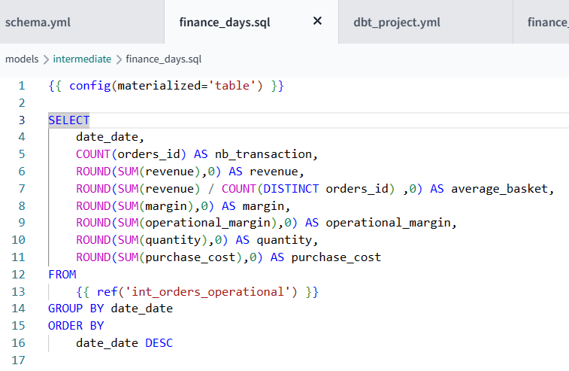

1. Build your model and check on BigQuery

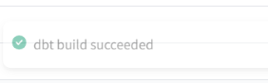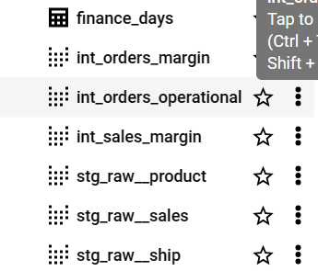

Actually, we would like this configuration to be valid for all mart models.

Let’s make the all the tables in the mart folder materialized as tables.

1. Edit the config file of your project dbt_project.yml
2. Remove the specific configuration in finance_days.sql

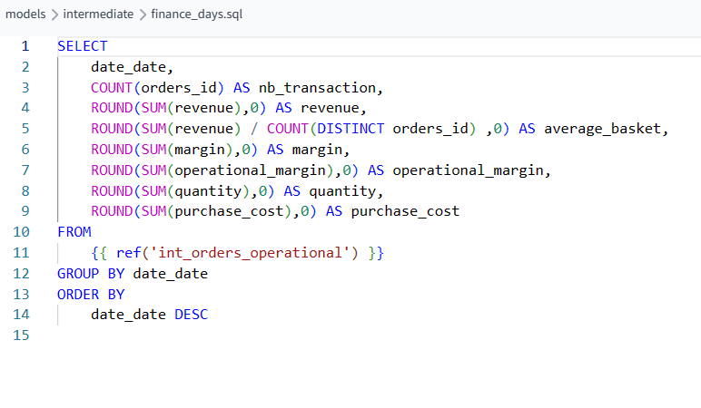

**2 - Project Structure Database Target**

We want all the mart models to target a specific dataset in the warehouse, corresponding to the business team that will use it.

1. Add a folder in mart corresponding to the business i.e. finance

صورة تحتوي على نص, لقطة شاشة, الخط

تم إنشاء الوصف تلقائياً

1. Move your finance model inside this folder

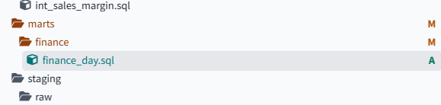

1. Edit your dbt_project.yml to change the target of a new folder

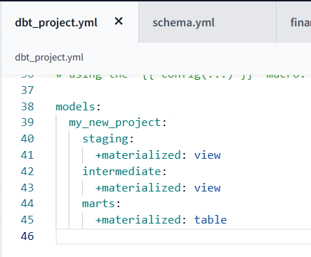

1. Run the dbt build command.

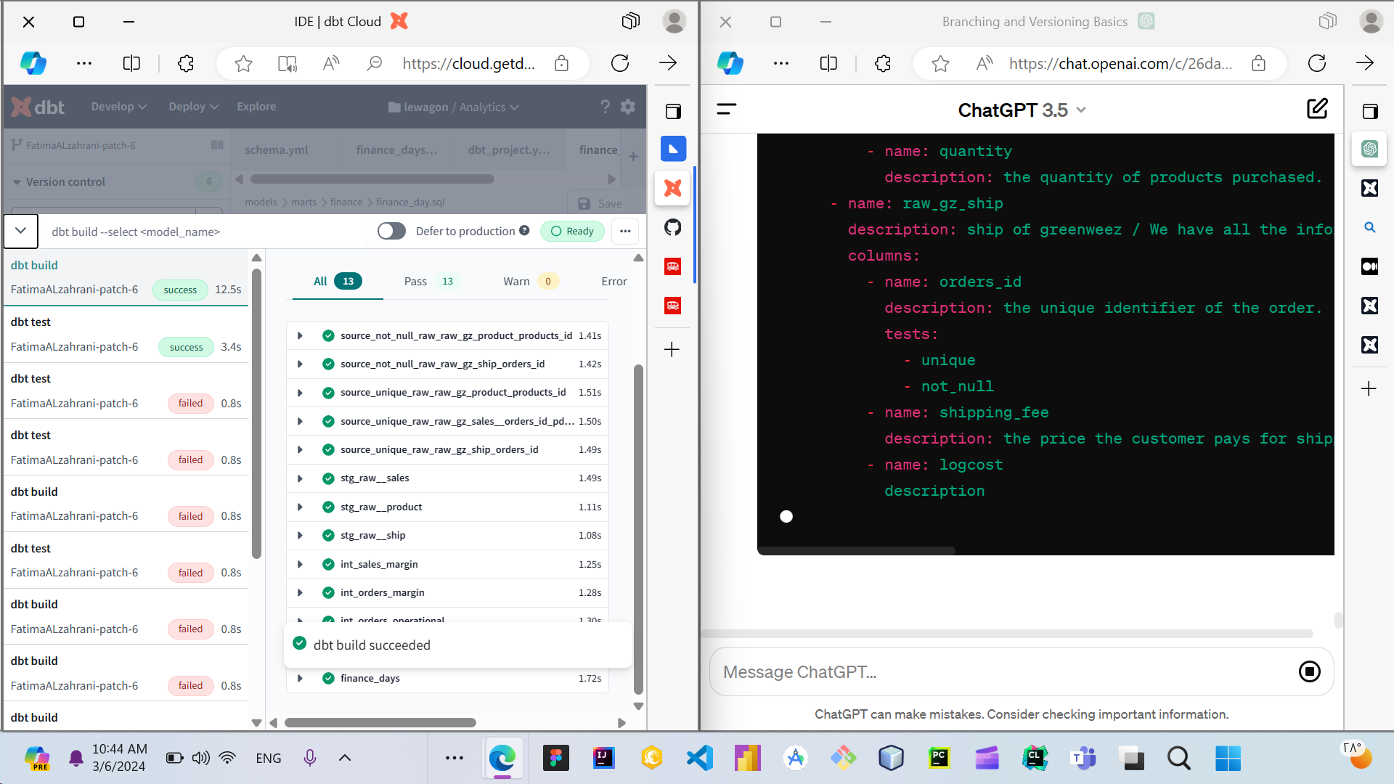

1. Check in BigQuery the structure and the icon of table:

